
IOW Adoption Centre
Application for Volunteer Cat Foster Carer
A huge thank you for your interest in becoming a cat foster carer! You really will make a big difference in helping us give homeless cats and kittens a second chance in life.
We can’t wait to welcome you as part of our volunteer fostering team. To get things started, we would be very grateful if you could spare a few minutes to give us a little more detail about yourself and your home.

CONTACT DETAILS
Name:
Email Address:
Address:
Telephone Number:

YOUR HOME AND YOUR HOUSEHOLD
- Do you own your own property? If not, are you allowed to have a cat in your property under the terms of your tenancy agreement? (We will need to see a copy of your agreement and/or a letter from your landlord giving permission)
- How many adults are there in your household?
- How many children are there in your household? And how old are they? (Please remember that children must be supervised at all times with your foster cat)
- Is everyone in your household in agreement to the fostering of Cats Protection cats?
- Please give us details if you, or anyone else in your house, has a disability, chronic health issue, allergy or are immune compromised:

YOUR PETS
Please give details of previous experience (if any) with cats:

Please list any current pets in your home and whether they have been vaccinated in the past year:

LOOKING AFTER YOUR FOSTER CAT
- We will always advise you on the best fostering options for you, including the suitability of ‘single-room’ fostering or ‘whole-house’ fostering. The following information will help us in this process.
- On average, how many hours will your foster cat be left alone?
- Do you have a designated quiet and secure room to look after your foster cat as per below:
  - For SINGLE-ROOM fostering, would you be able (and prepared) to keep and look after your foster cat FOR THE DURATION of their foster care in a designated quiet and secure room, separated from other pets?
  - For WHOLE-HOUSE fostering, would you be able (and prepared) to start your foster cat for a short time (to be advised by Cats Protection) in a designated quiet room while they adjust to the new environment?
- Are you willing to use your car to transport your foster cat/cat food/supplies etc?
- Would you be happy to foster any of the following:
- Pregnant cat YES / NO
  - Cat and litter of kittens YES / NO
  - Weaned kittens without a mum YES / NO
  - A cat being very timid and hiding away YES / NO
- Sometimes it may be necessary to give medication. Please indicate below if you would be comfortable giving medication in the following ways:
- ORAL - YES / NO
- TABLET/LIQUID (IN FOOD) - YES / NO
- INJECTION - YES / NO
(NB: Full training will be given but please note that medication must always be kept in a secure place and that children are not permitted to administer or help administer any medication to your foster cat)
Eventually, your foster cat be adopted and go to their forever home. Understandably, this may be upsetting for you. How will you manage this?

Because we would love to attract more foster carer volunteers, it would be really helpful if you could tell us how you found out about this volunteer opportunity:
……………………………………………………………………………………………………………………………………………………………
Thank you so much for taking the time to complete this form If there are any other details or information that you feel may be relevant, please add them in the space below:

MEDICAL DECLARATION
For your wellbeing and safety we need to know that you are fit to carry out your role as a fosterer, therefore please would you please sign the declaration below. ‘To the best of my knowledge, I am fit to carry out the role of fosterer I have applied for’

Signature/date ……………………………………………………………………………………………………………………
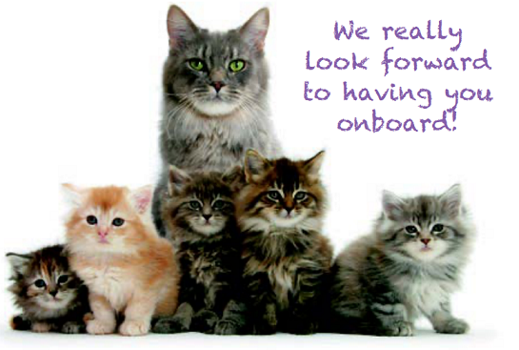
DATA PROTECTION – YOUR DATA We may store your details on computer for administration purposes but will not keep them longer than necessary. We may use your details to support the work of the charity and to contact you about our products or services. Under the Data Protection Act, you are entitled to a copy of the information we hold about you although we are entitled to ask you to pay for this. With your permission, we may share information with other carefully selected companies or our trading subsidiary. We would be grateful if you could indicate your preferences below:
(1) Would you like to receive further updates and communication from Cats Protection? YES / NO
(2) Would you like to receive relevant offers from carefully selected companies? YES / NO
(3) Would you like to receive communications by email? YES / NO

